**Yog Chaudhary**

**11727095**

**ADTA 5550: Deep Learning with Big Data**

**Professor: Dr. Hamidreza Moradi**

**University of North Texas Jan 22, 2024**

**PART I: Confirm UNT Student Email Address**

Emailed it as given in the screenshot.

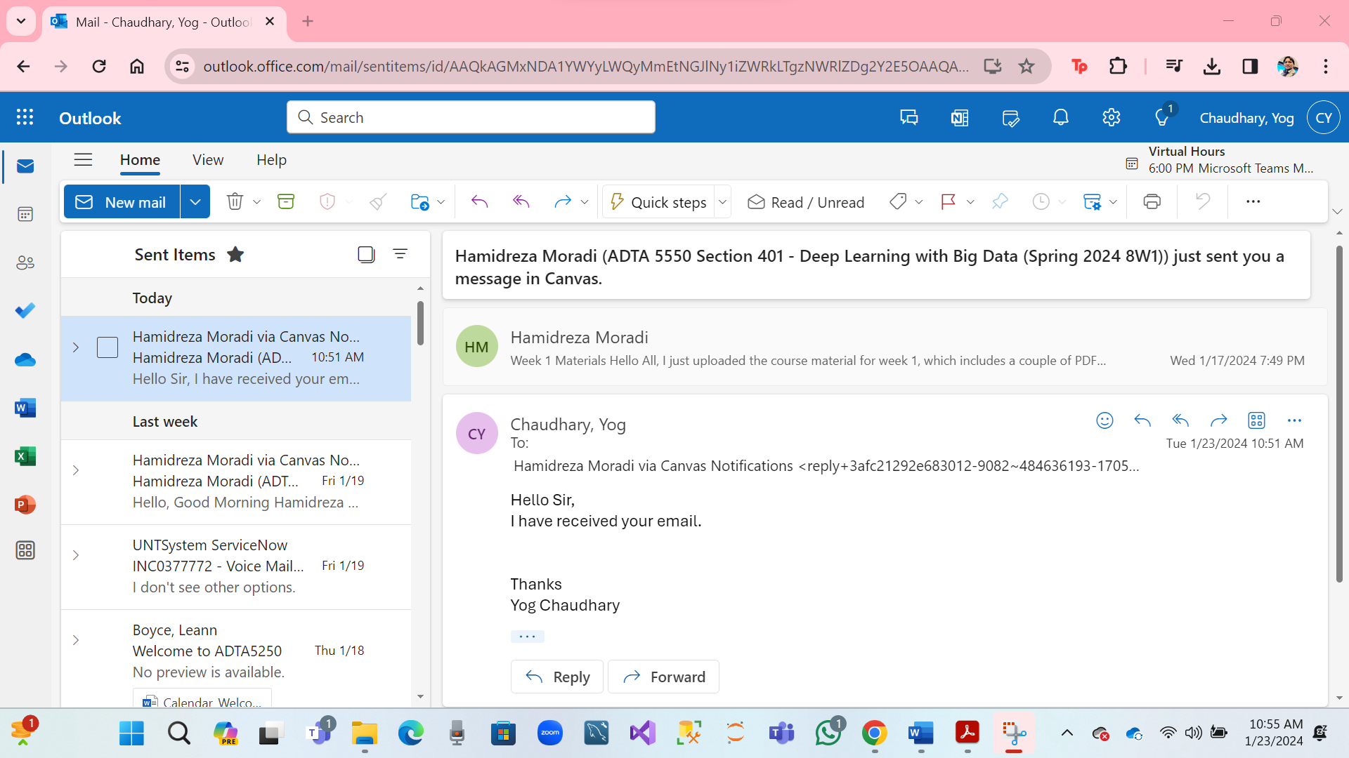

**PART II: Select an Operating System.**

I will be using Windows as an OS for this course, and good knowledge of drive, directions and folders, files, the ownership status of these components, and administrative privileges.

We can create new folders, access existing ones along with their actual contents, and create and save files within these folders. Download software applications, store them in specific folders, and install these applications in real, physical directories. I can also open terminals in the Windows environment and run command lines for various tasks. Windows offers a user-friendly interface for all these actions, making it convenient for this course.

**PART III: Set Up Deep Learning Virtual Machine (VM) in GCP (20 Points)**

* Click on open GCP.
* Click on Free Trail.
* Enable Computing Engine

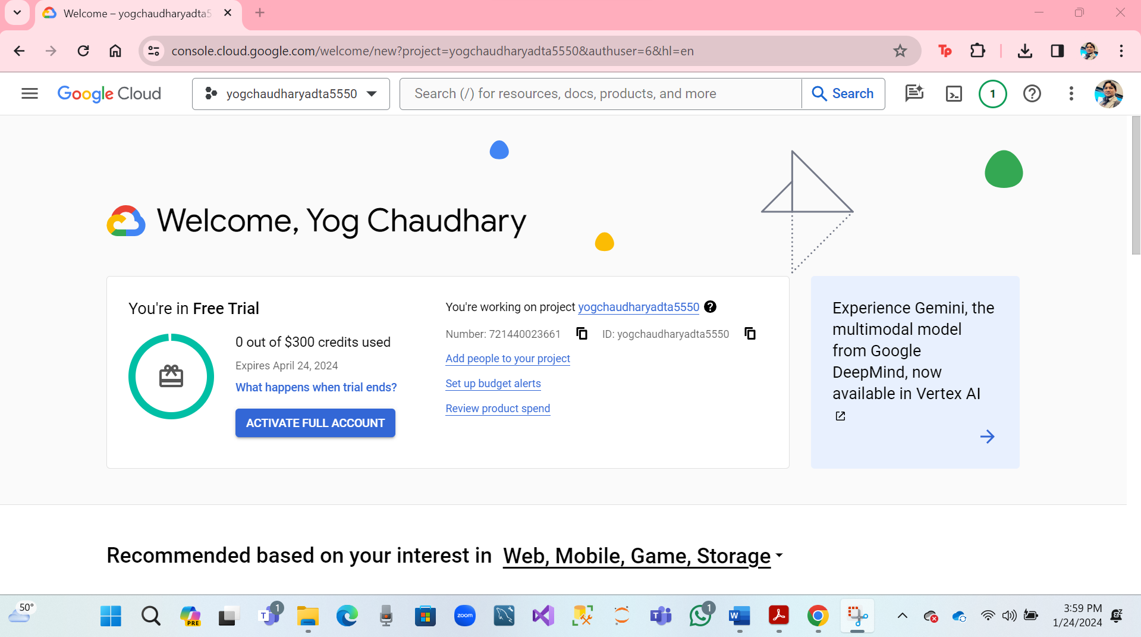

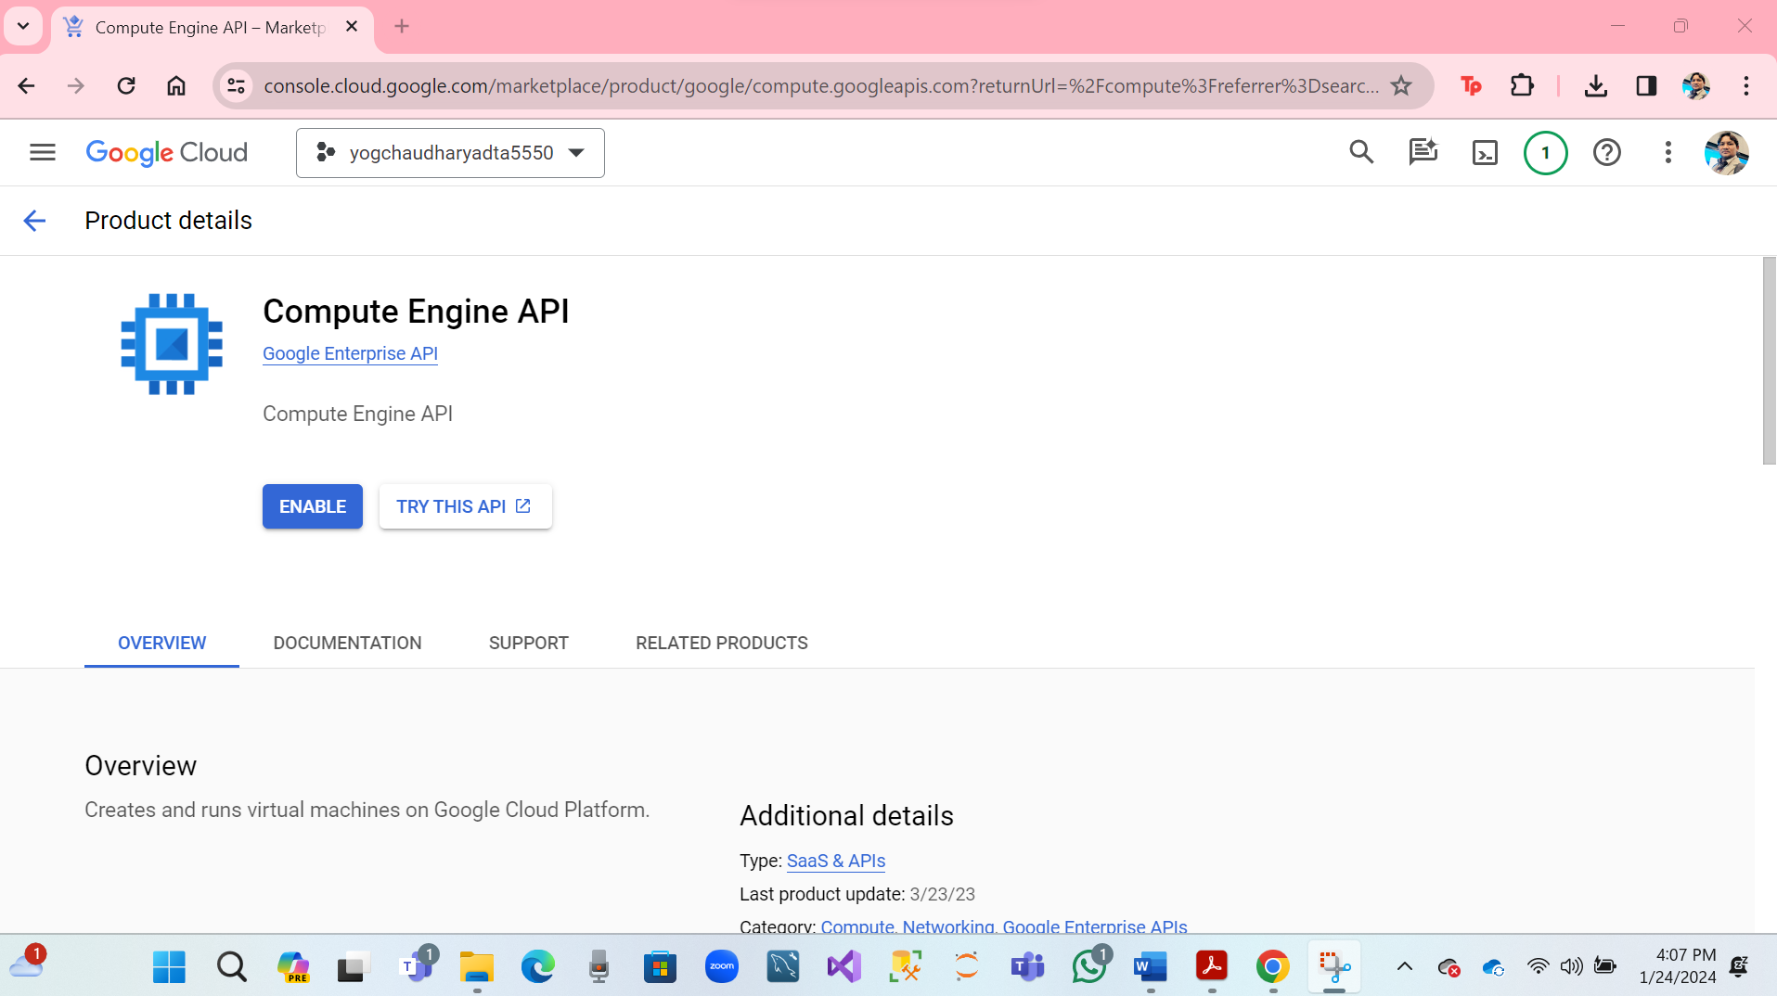

* Click on Enable Computing Engine.

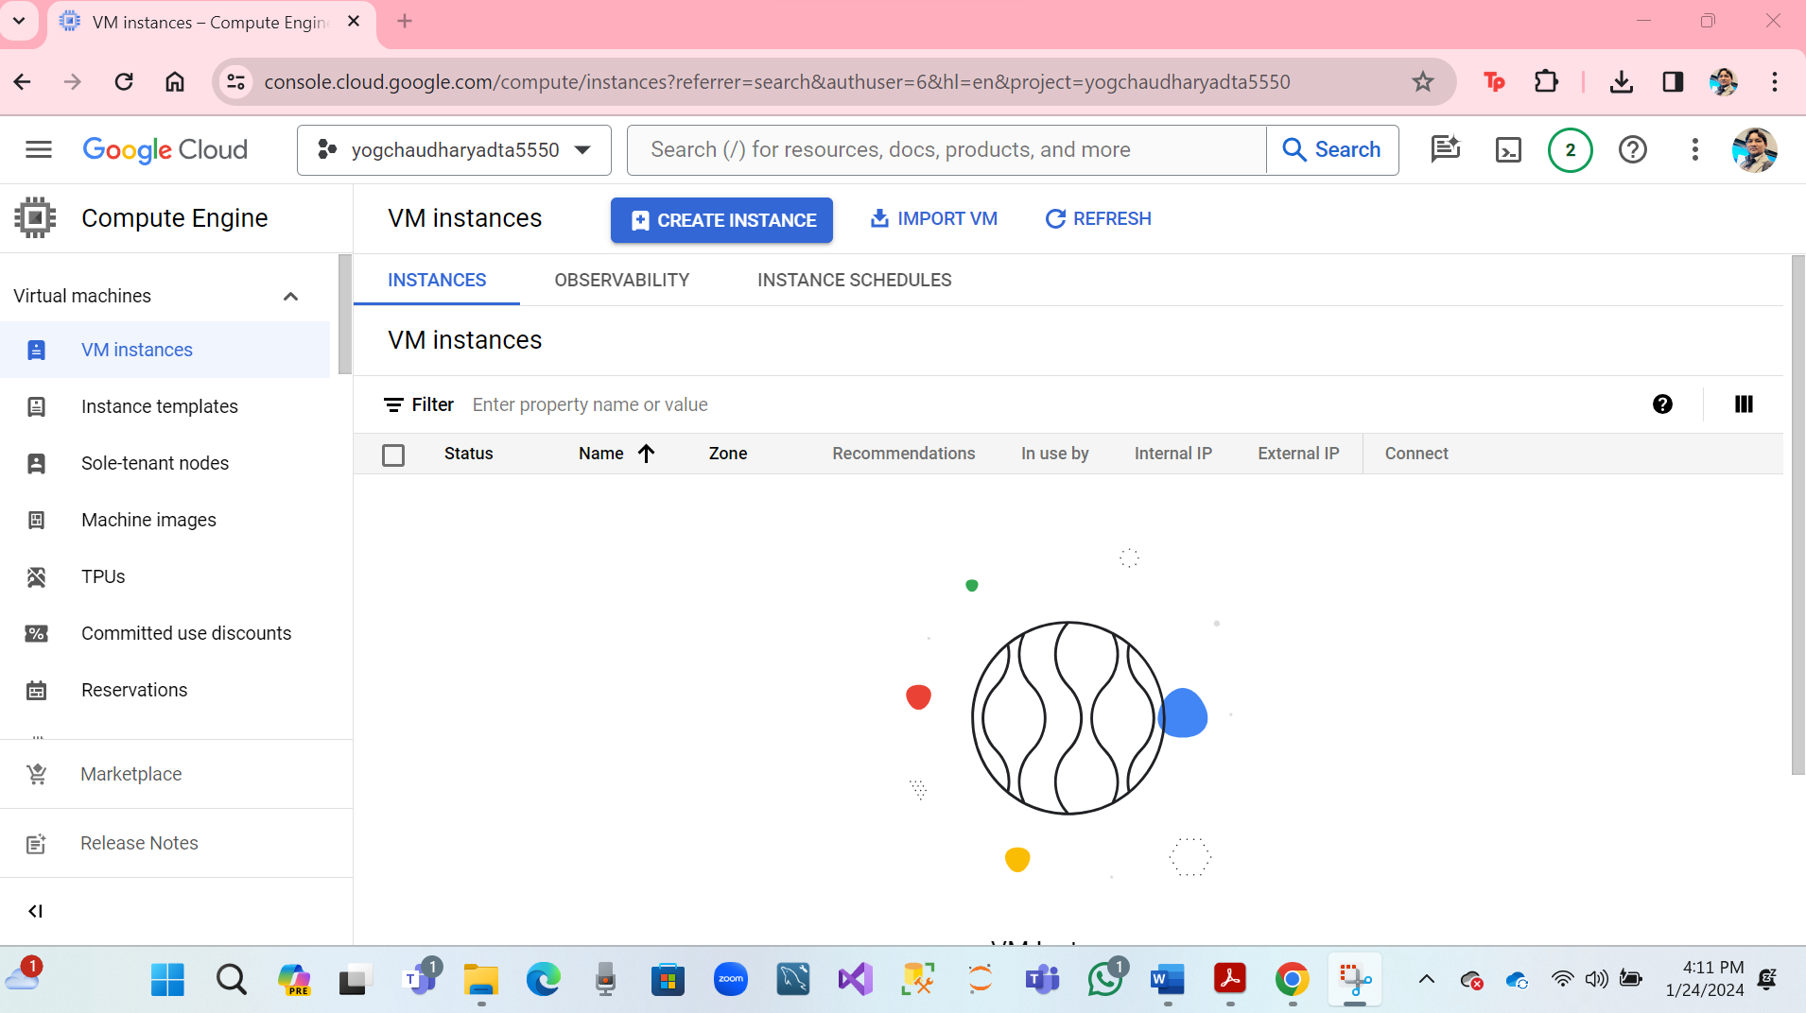

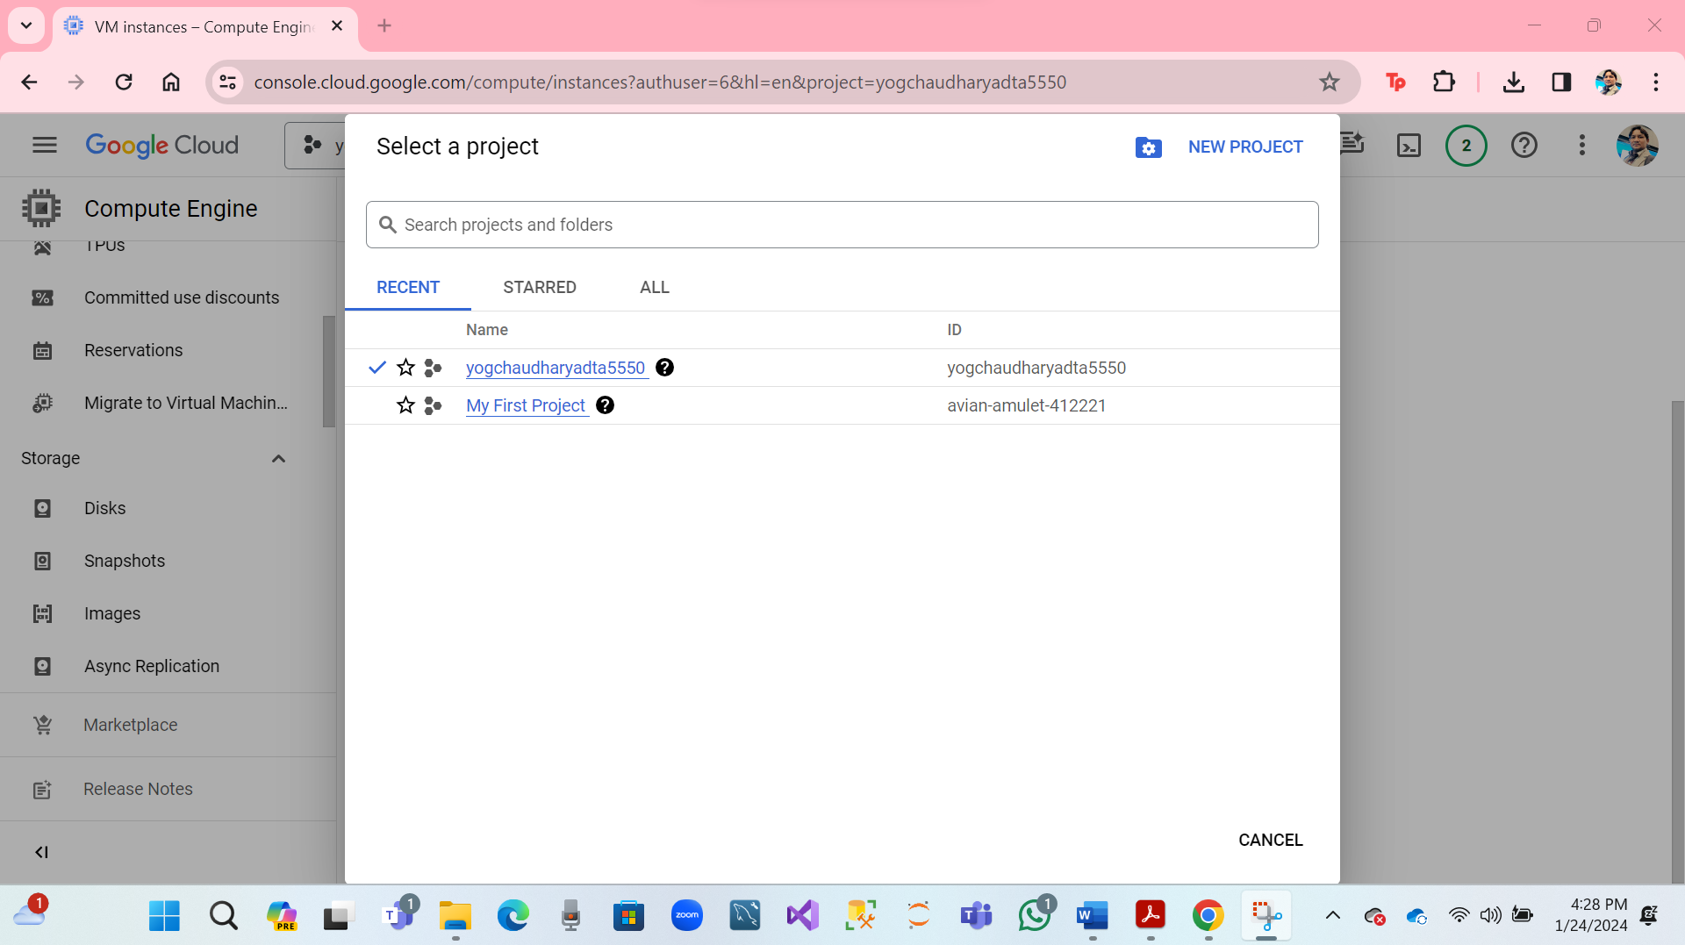

* Click on VM Instances
* Click on the search bar and click on cloud shell.
* Continue
* **Create on Deep Learning VM Using GCP Deep Learning Images**

**Click on:** [**https://cloud.google.com/deep-learning-vm/**](https://cloud.google.com/deep-learning-vm/)

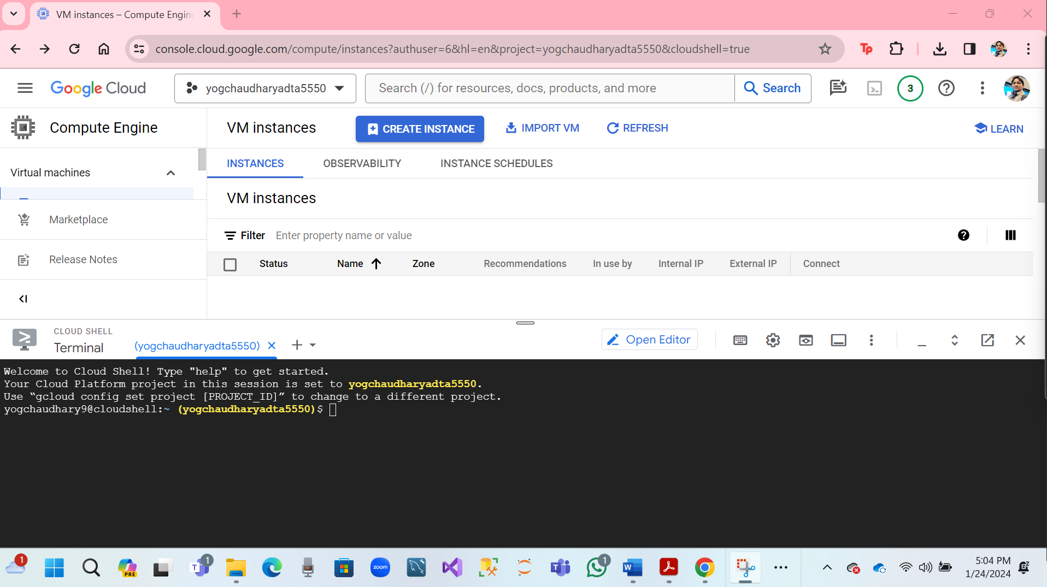

* **Drag tab a new window.**

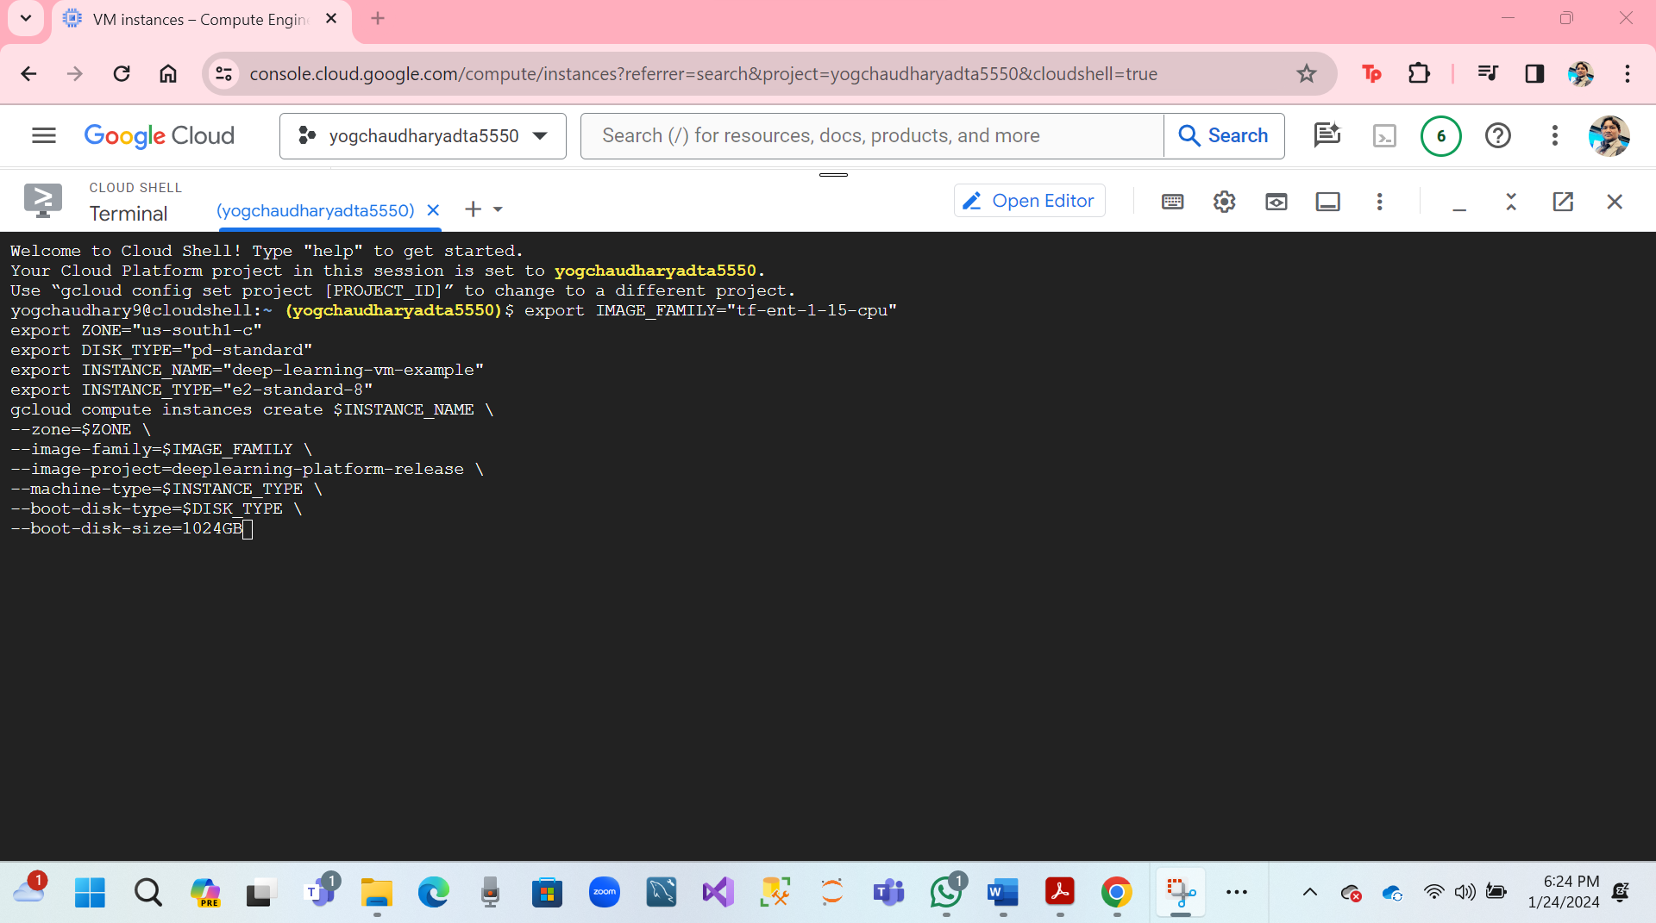

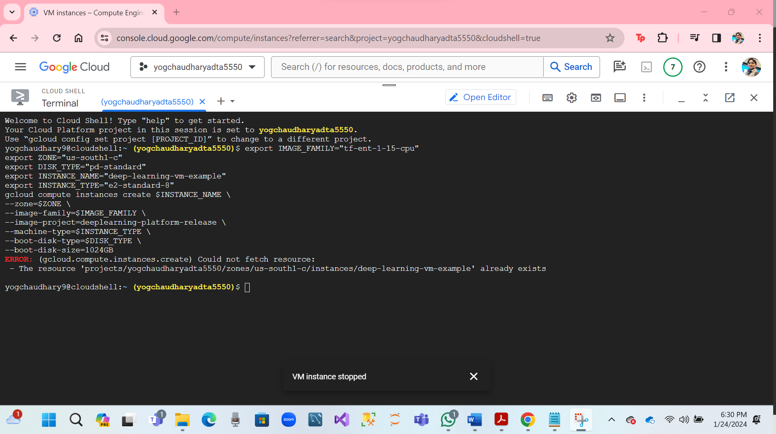

* Hare, we are sowing Deep Learning VM console.
* Name of Deep-learning-vm-example.
* Hare Screenshot.

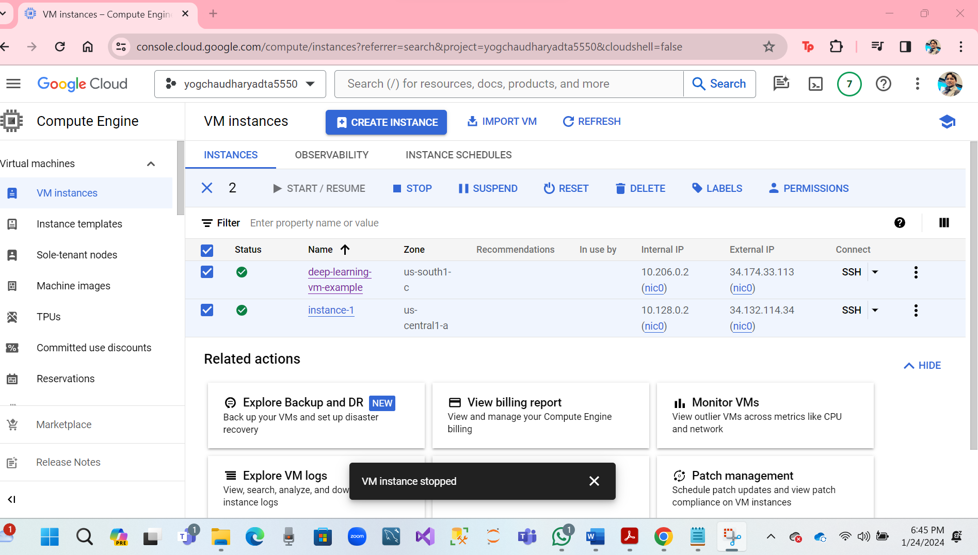

* **Verify the TensorFlow Enterprise version of the VM image.**

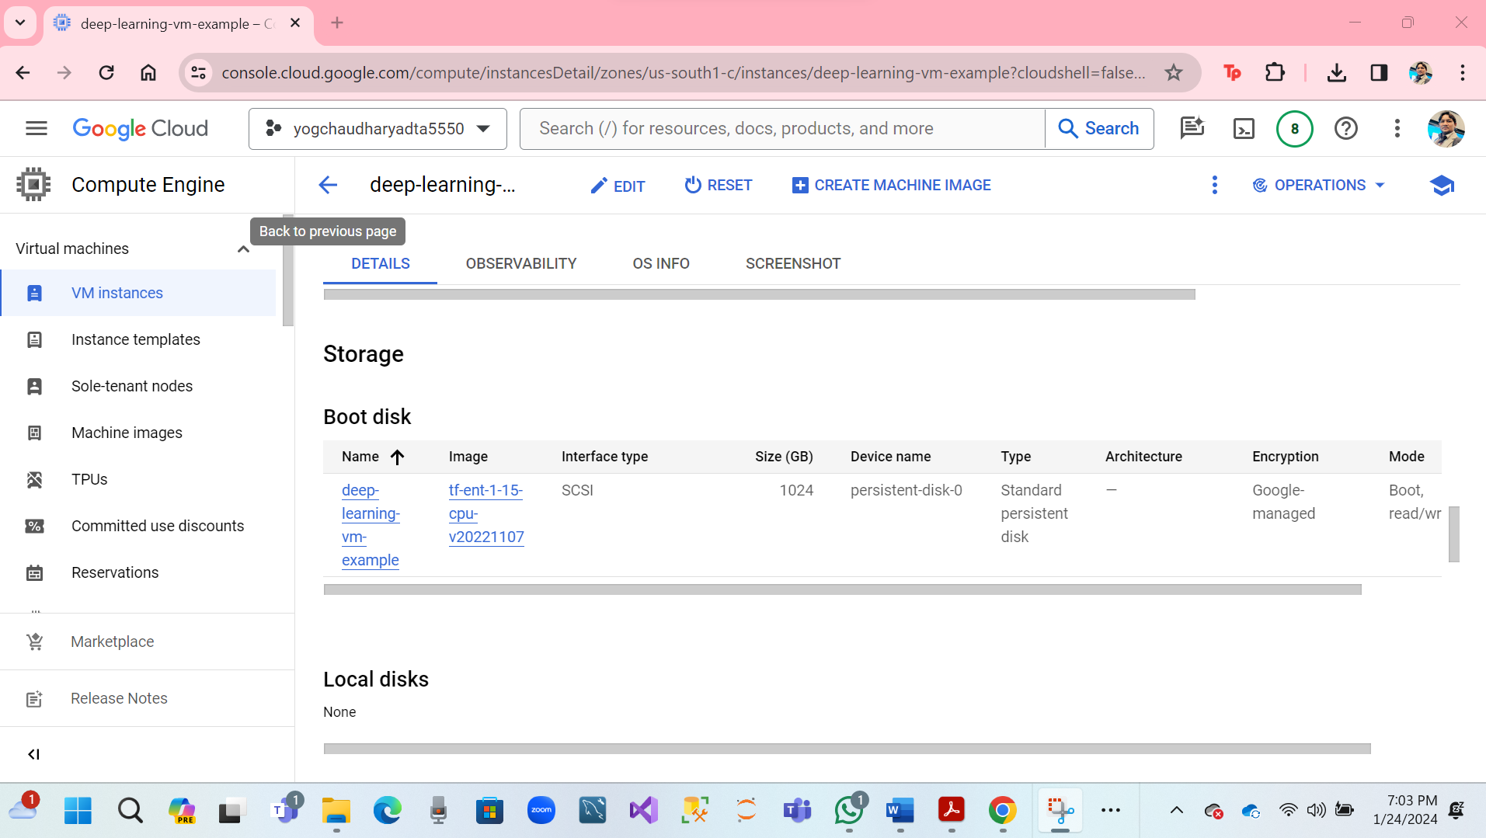

* **Deep Learning VM on GCP has been set up successfully.**
* **Access GCP Remote VM in the Console.**

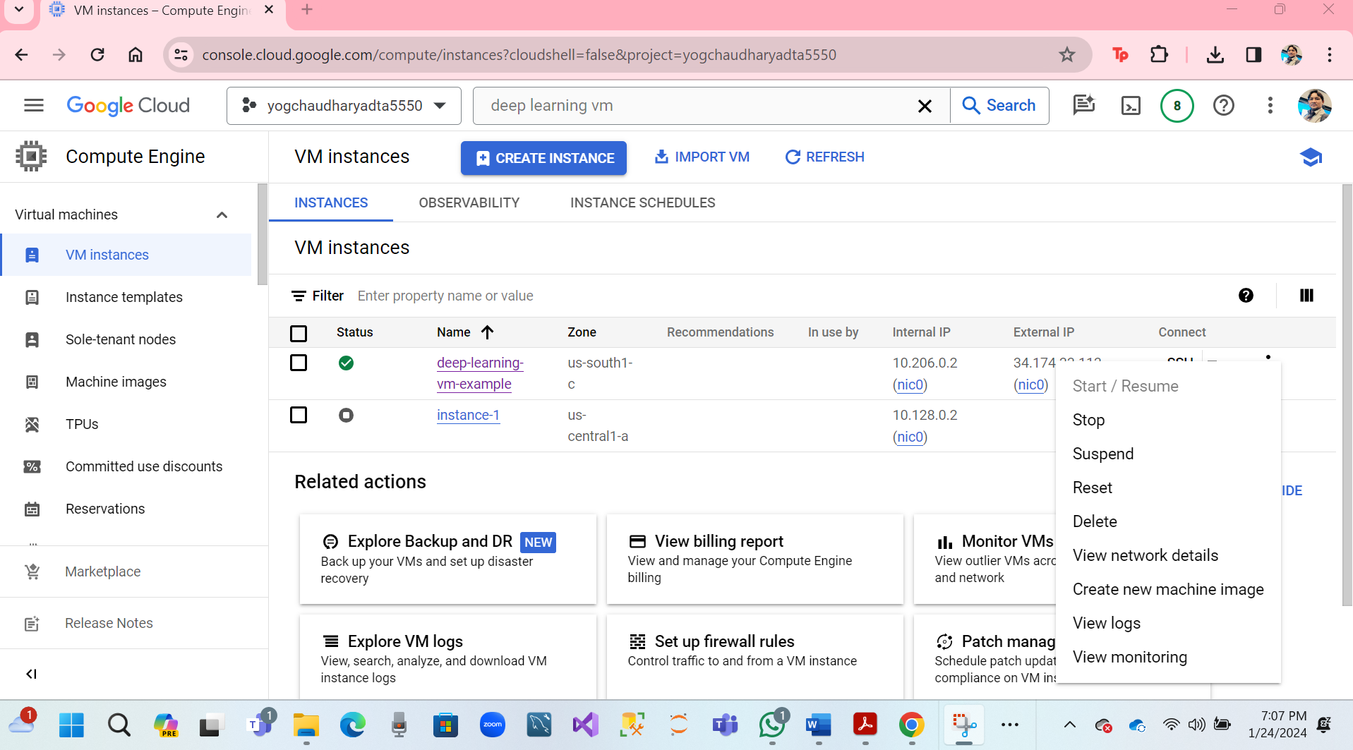

**Note: Stop it when not using.**

**2. Install on GCLOUD SDK**

* **Click on** <https://cloud.google.com/sdk/docs/install-sdk>

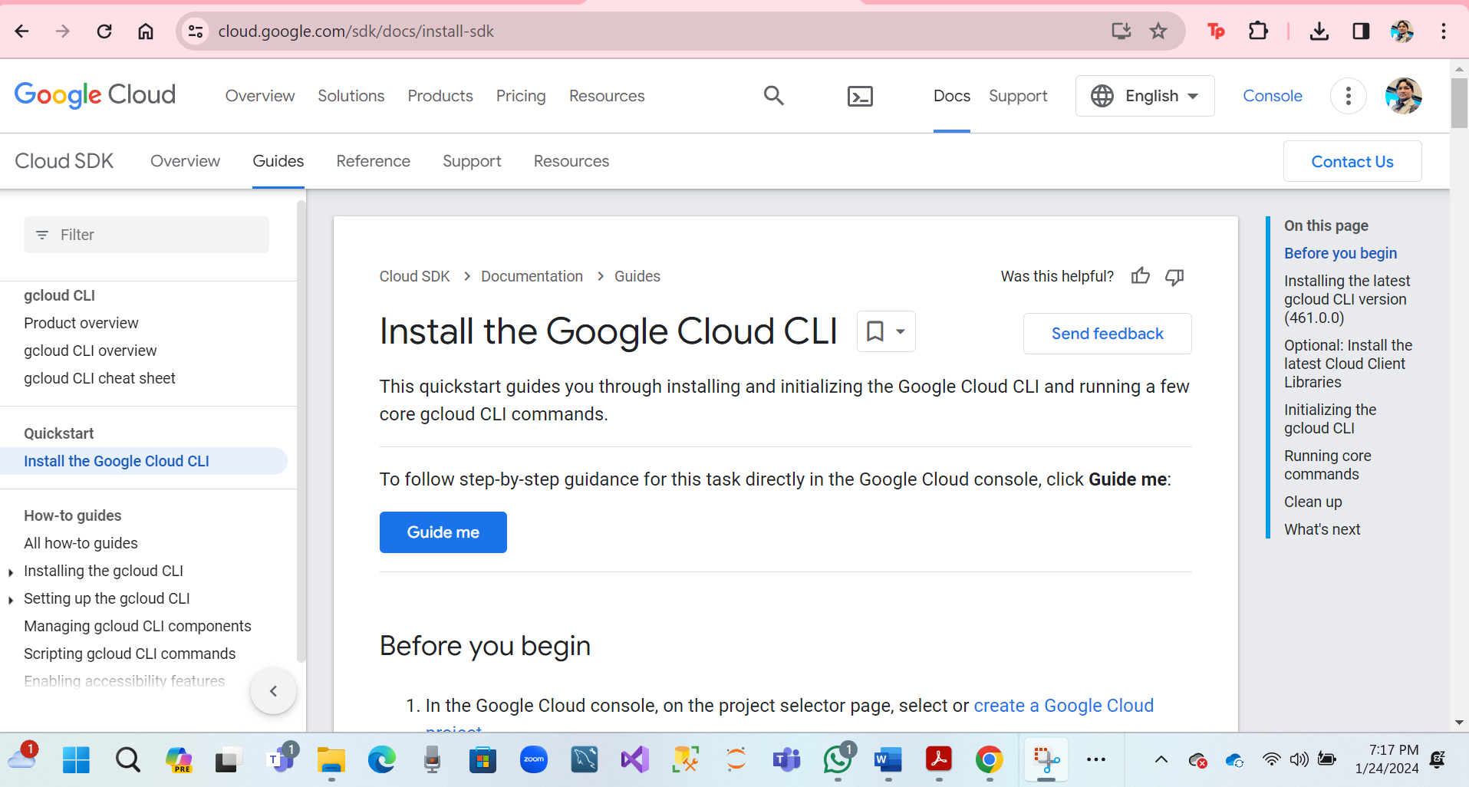

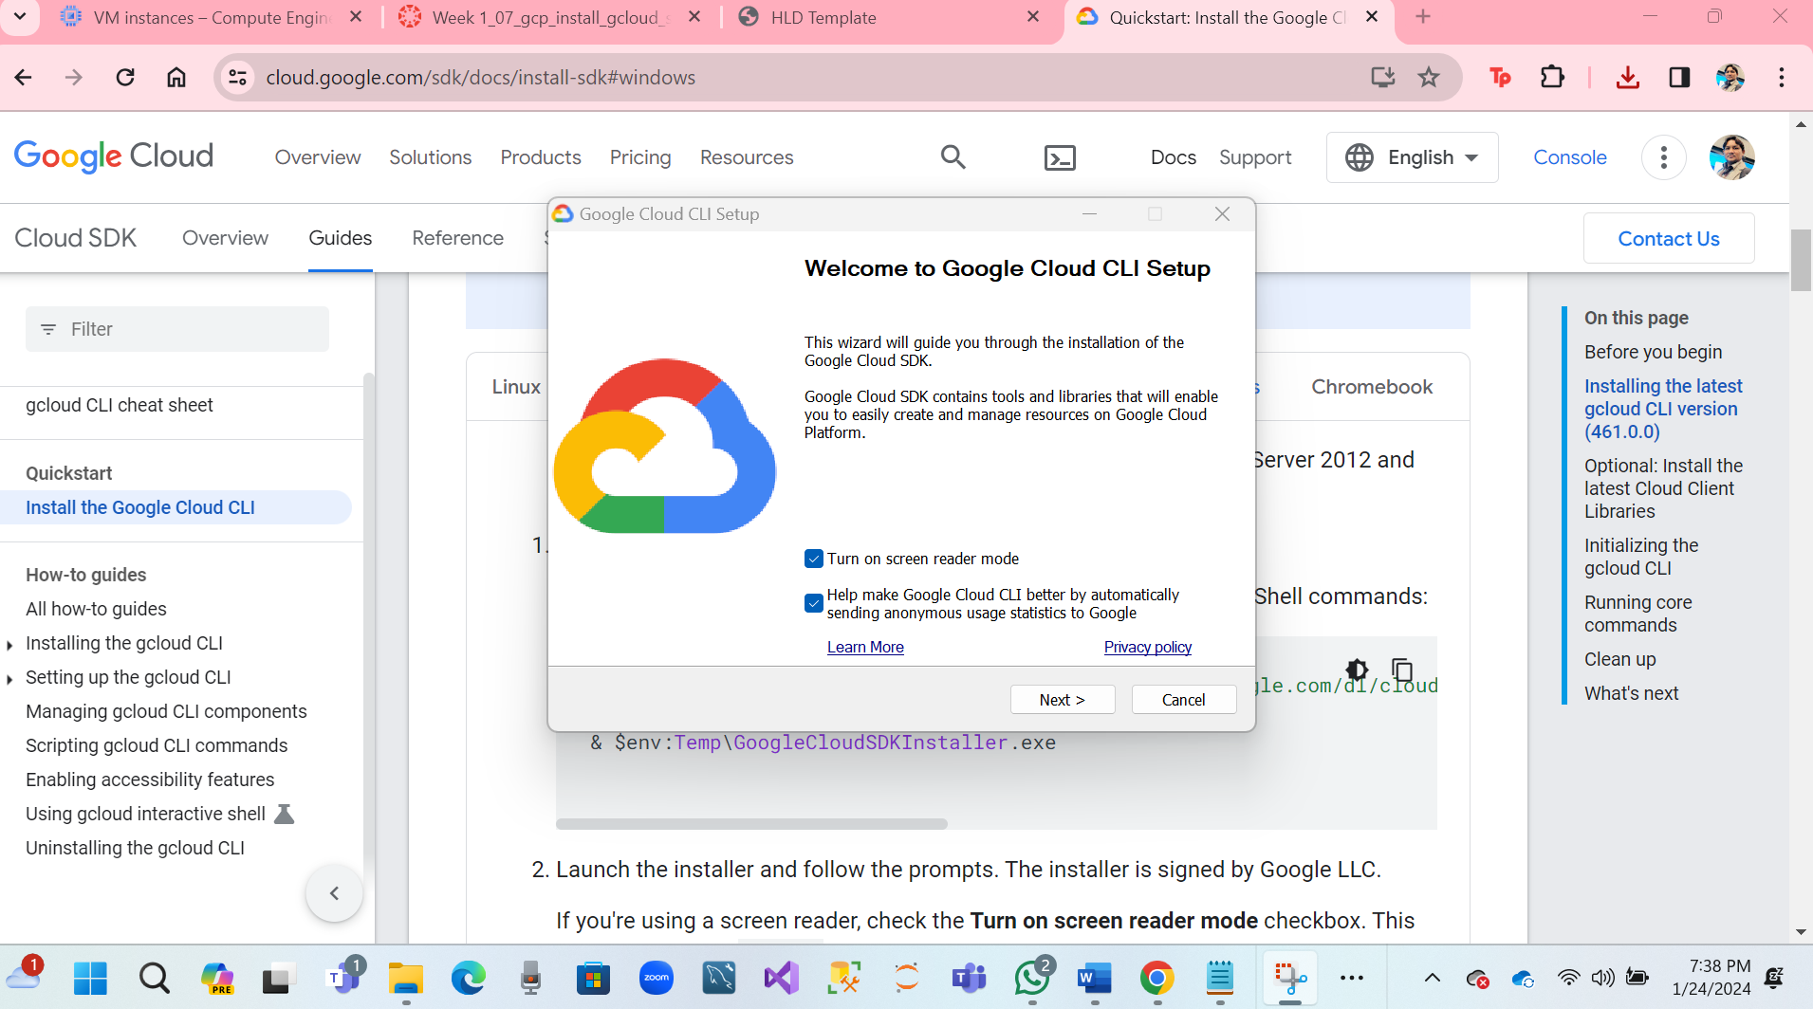

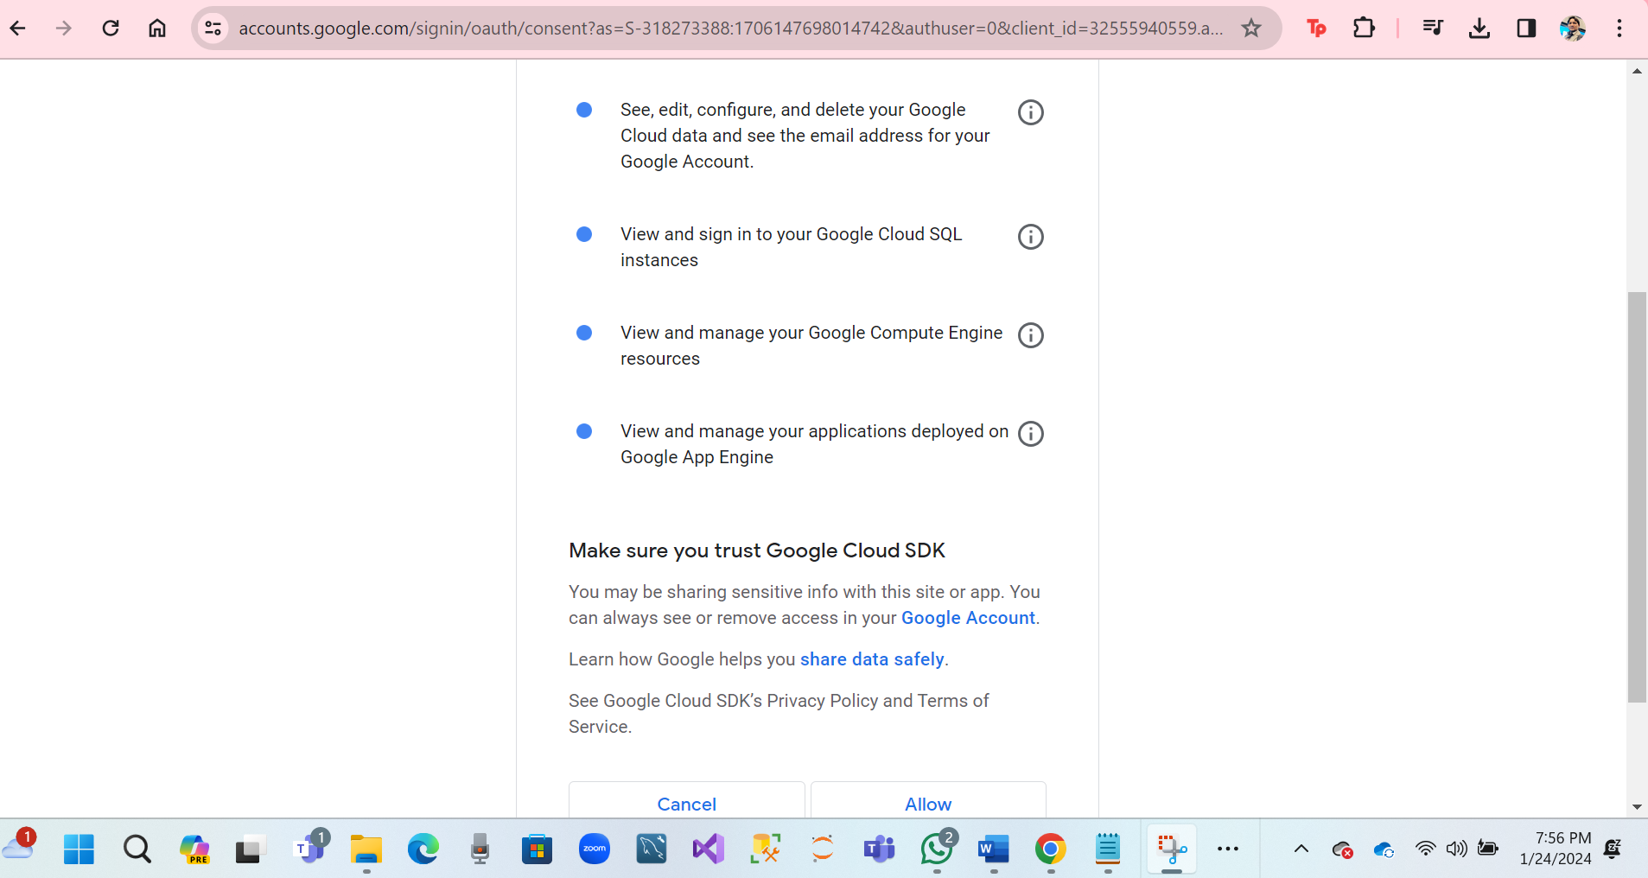

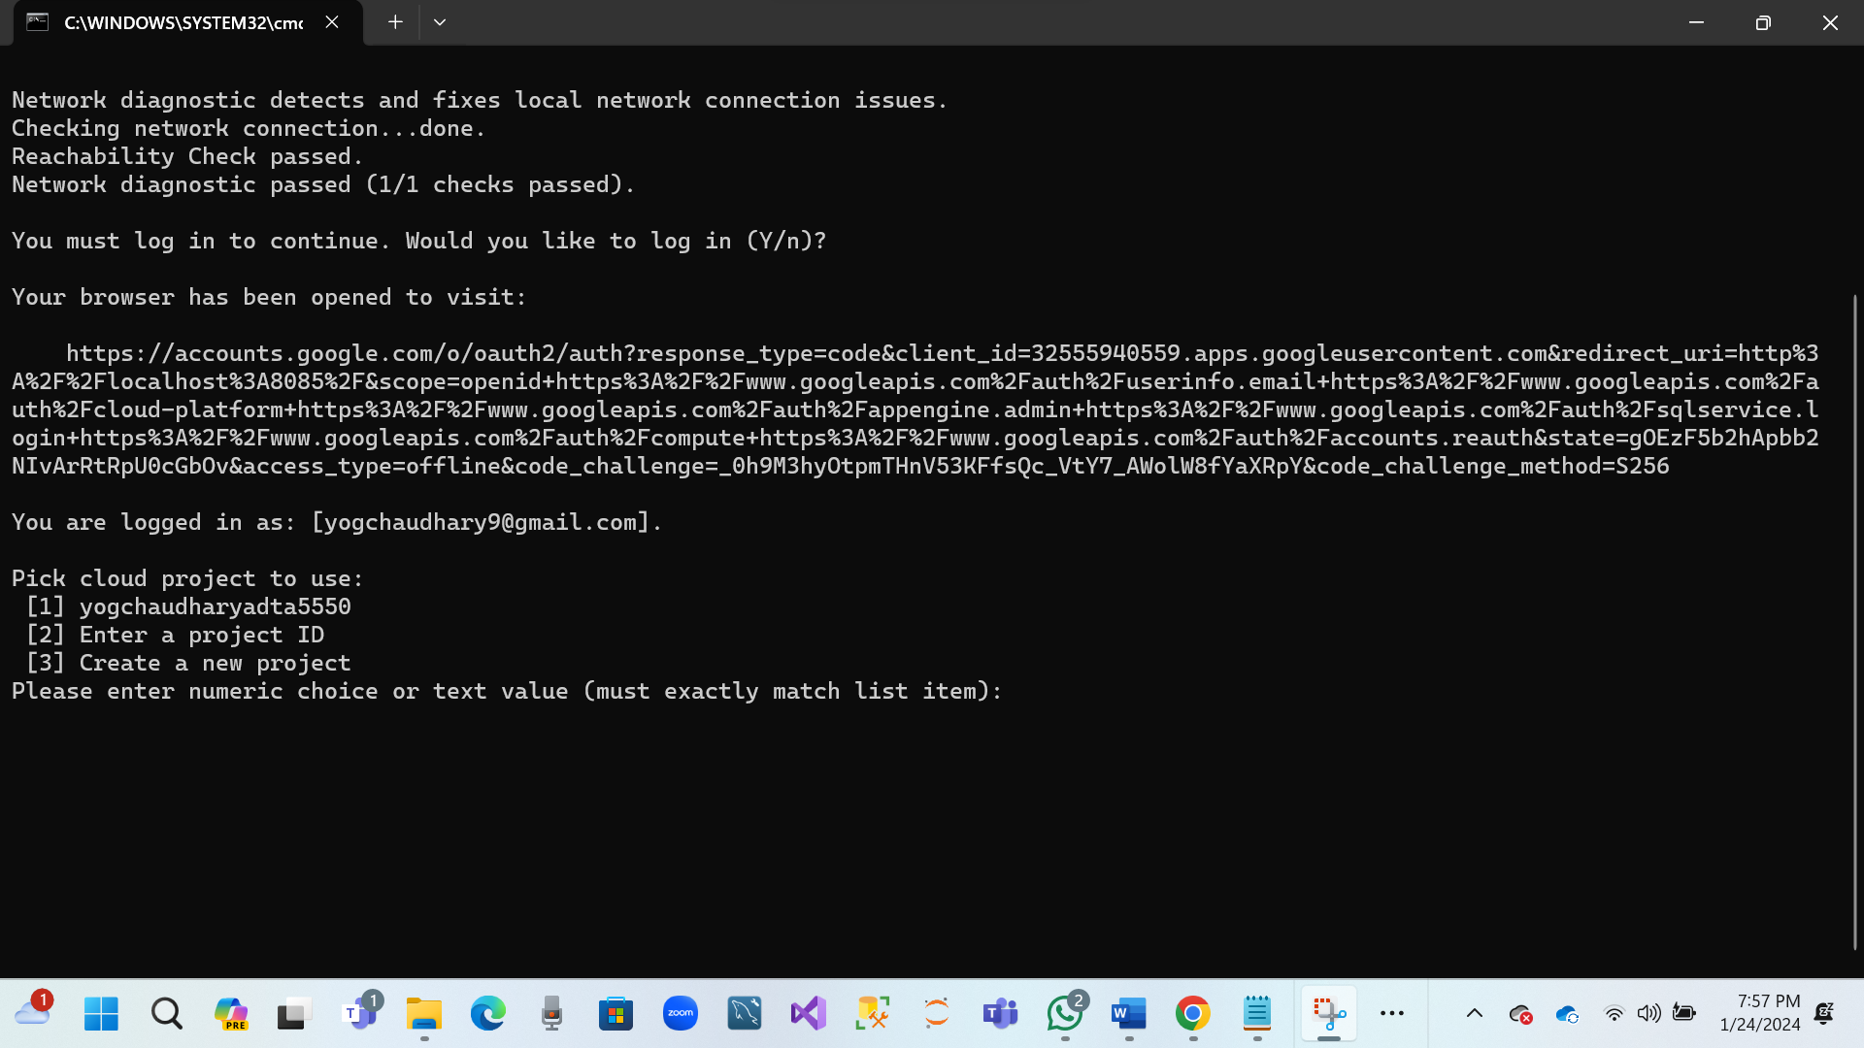

* **Finally, GCLOUD SDK has been successfully.**

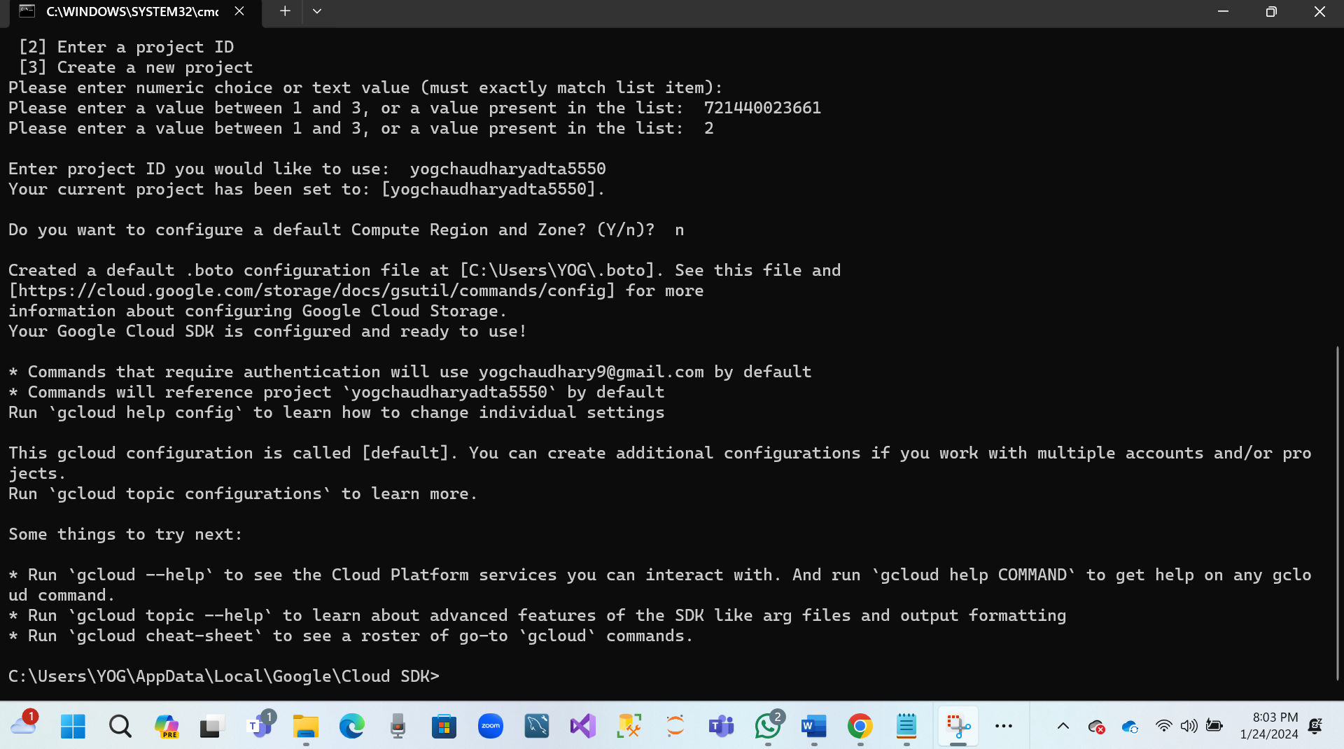

* **Run GCLOUD SDK Shell**
* **Hare screenshots**

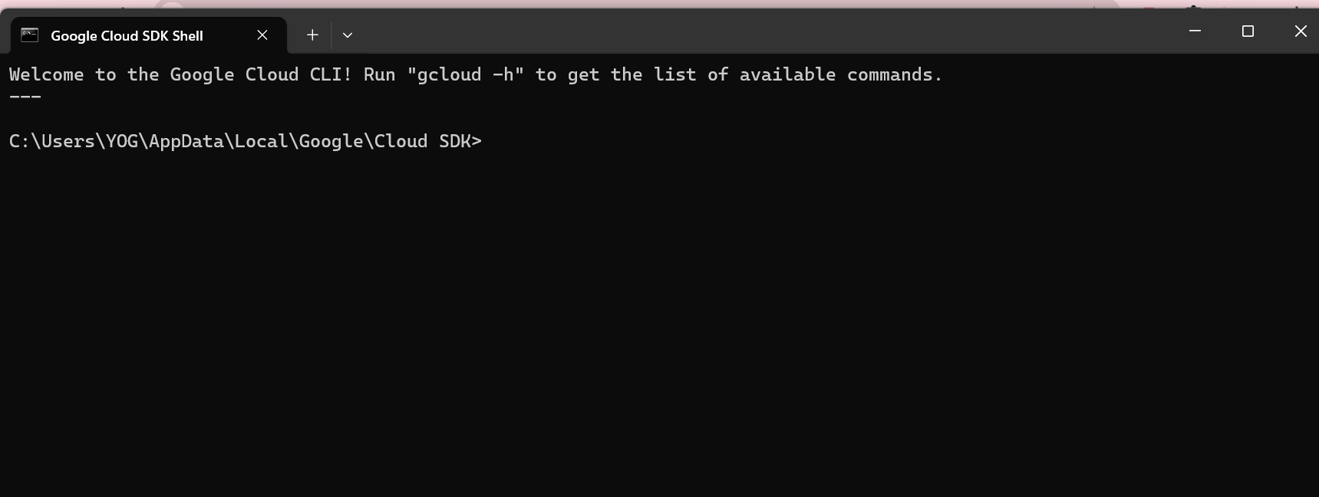

**PART IV: Connect and Explore Remote VM Using SSH**

**Question 3.1: Open an SSH connection from the local computer to the remote VM based on the lectures.**

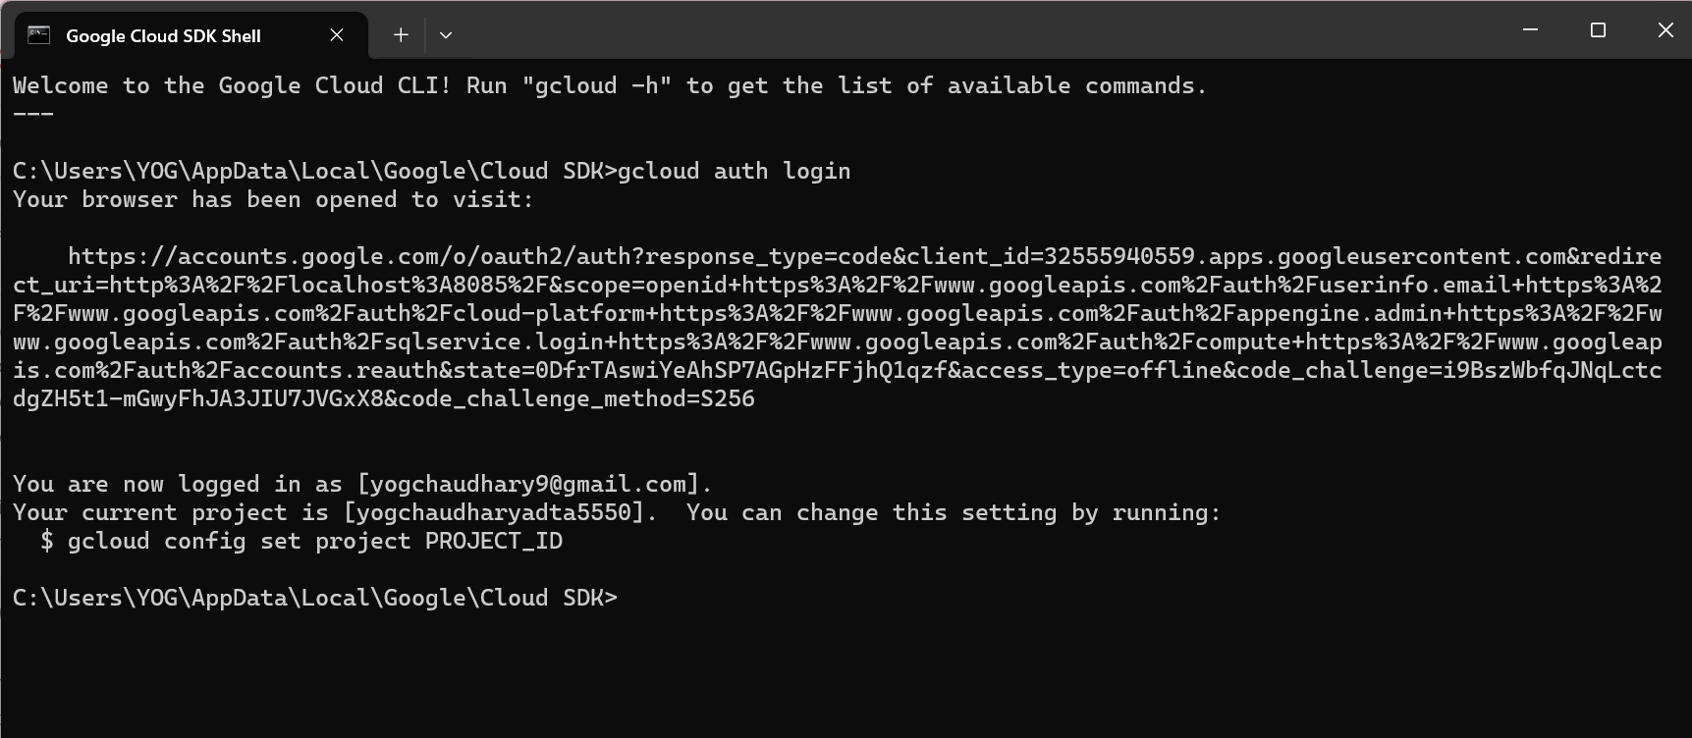

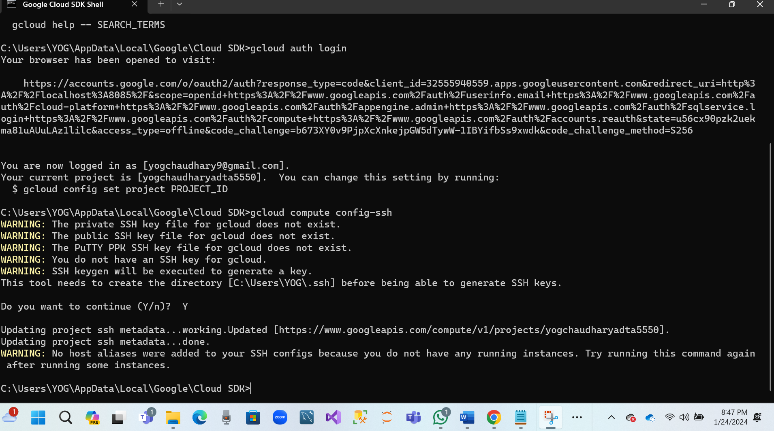

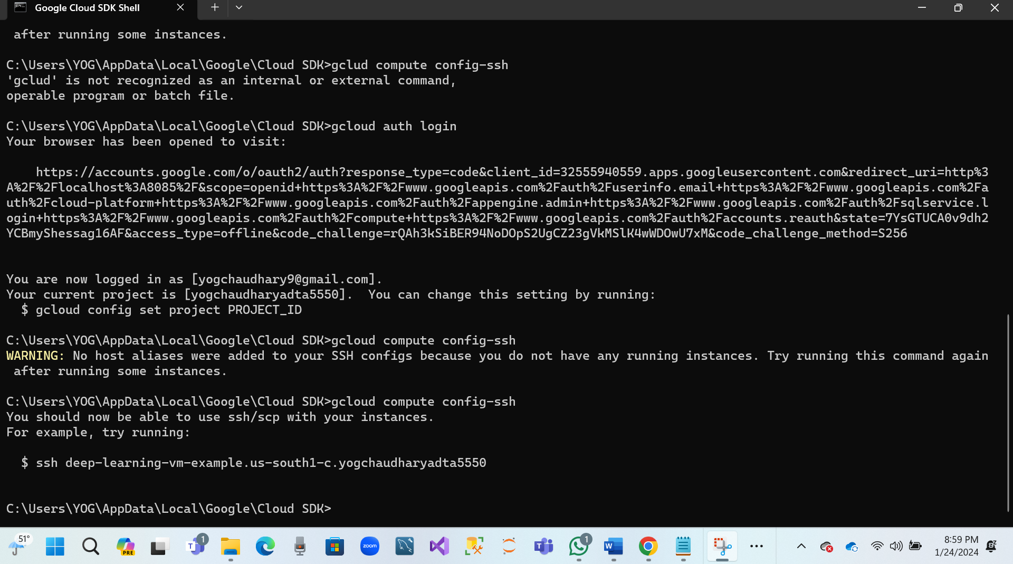

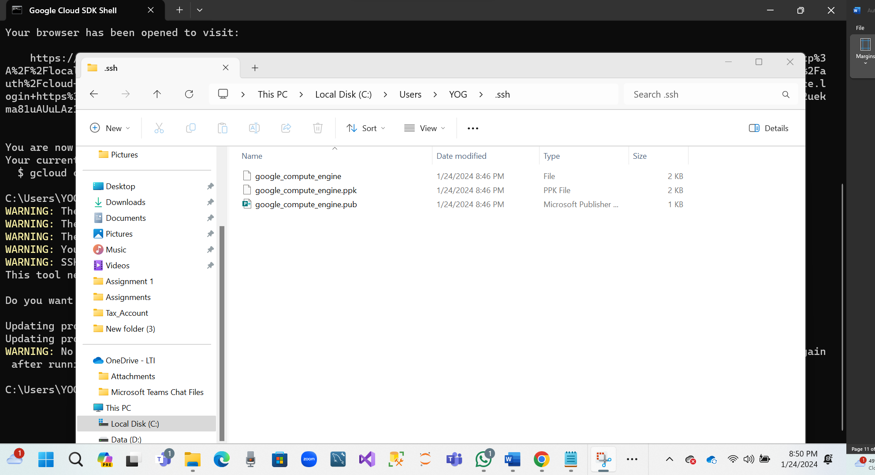

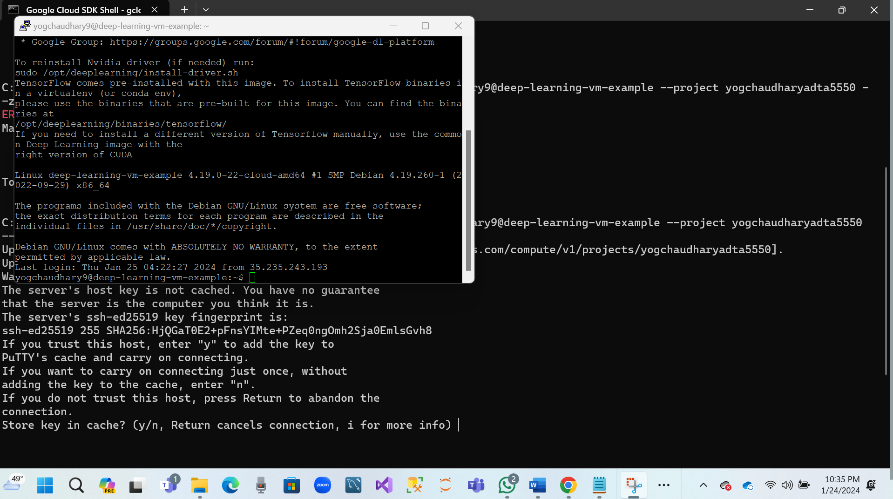

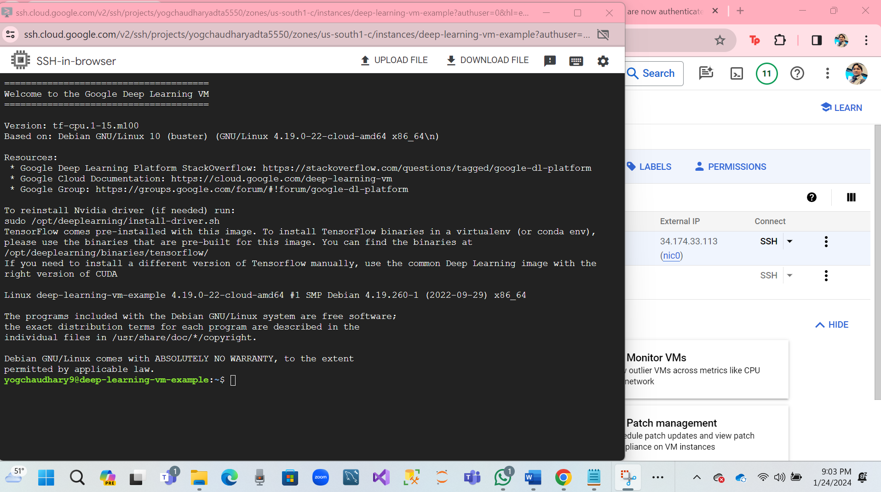

**Question 3.2 Using the basic Linux command lines to explore the contents of the home directory.**

* **whoami**
* **ls -l**
* **ls -all**

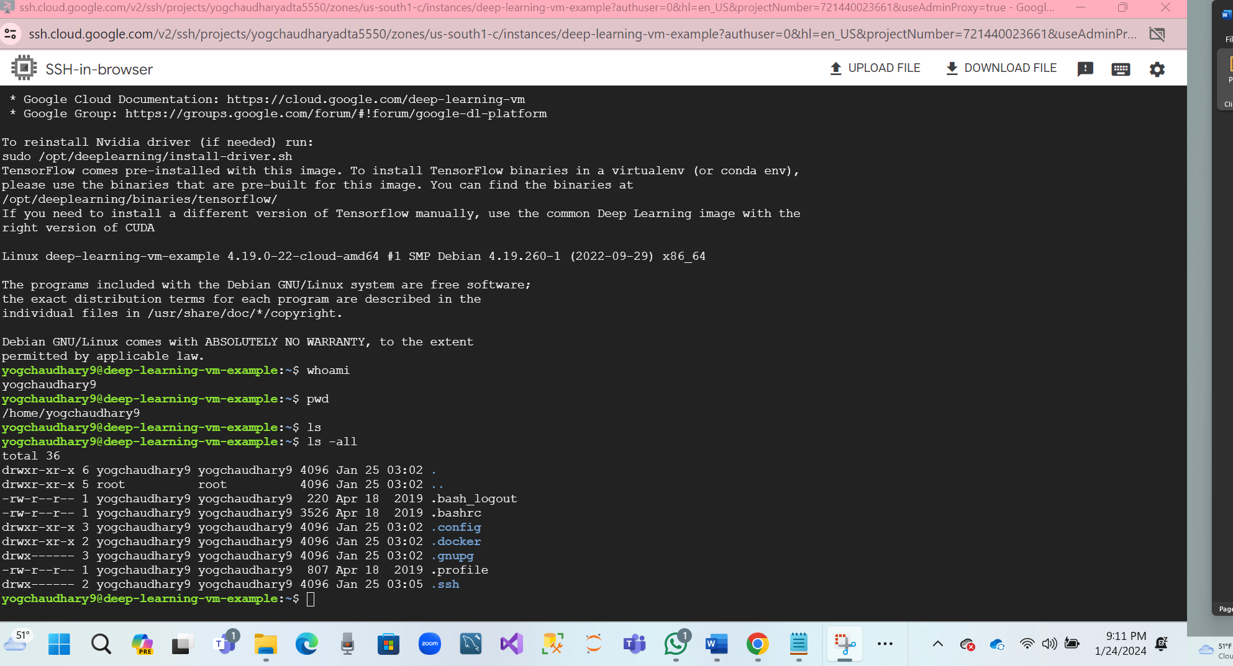

**Question 3.3 Create a new sub-folder named “JPTR_NTBK” under the home directory.**

* **mkdir JPTR_NTBK**
* **cd JPTR_NTBK**

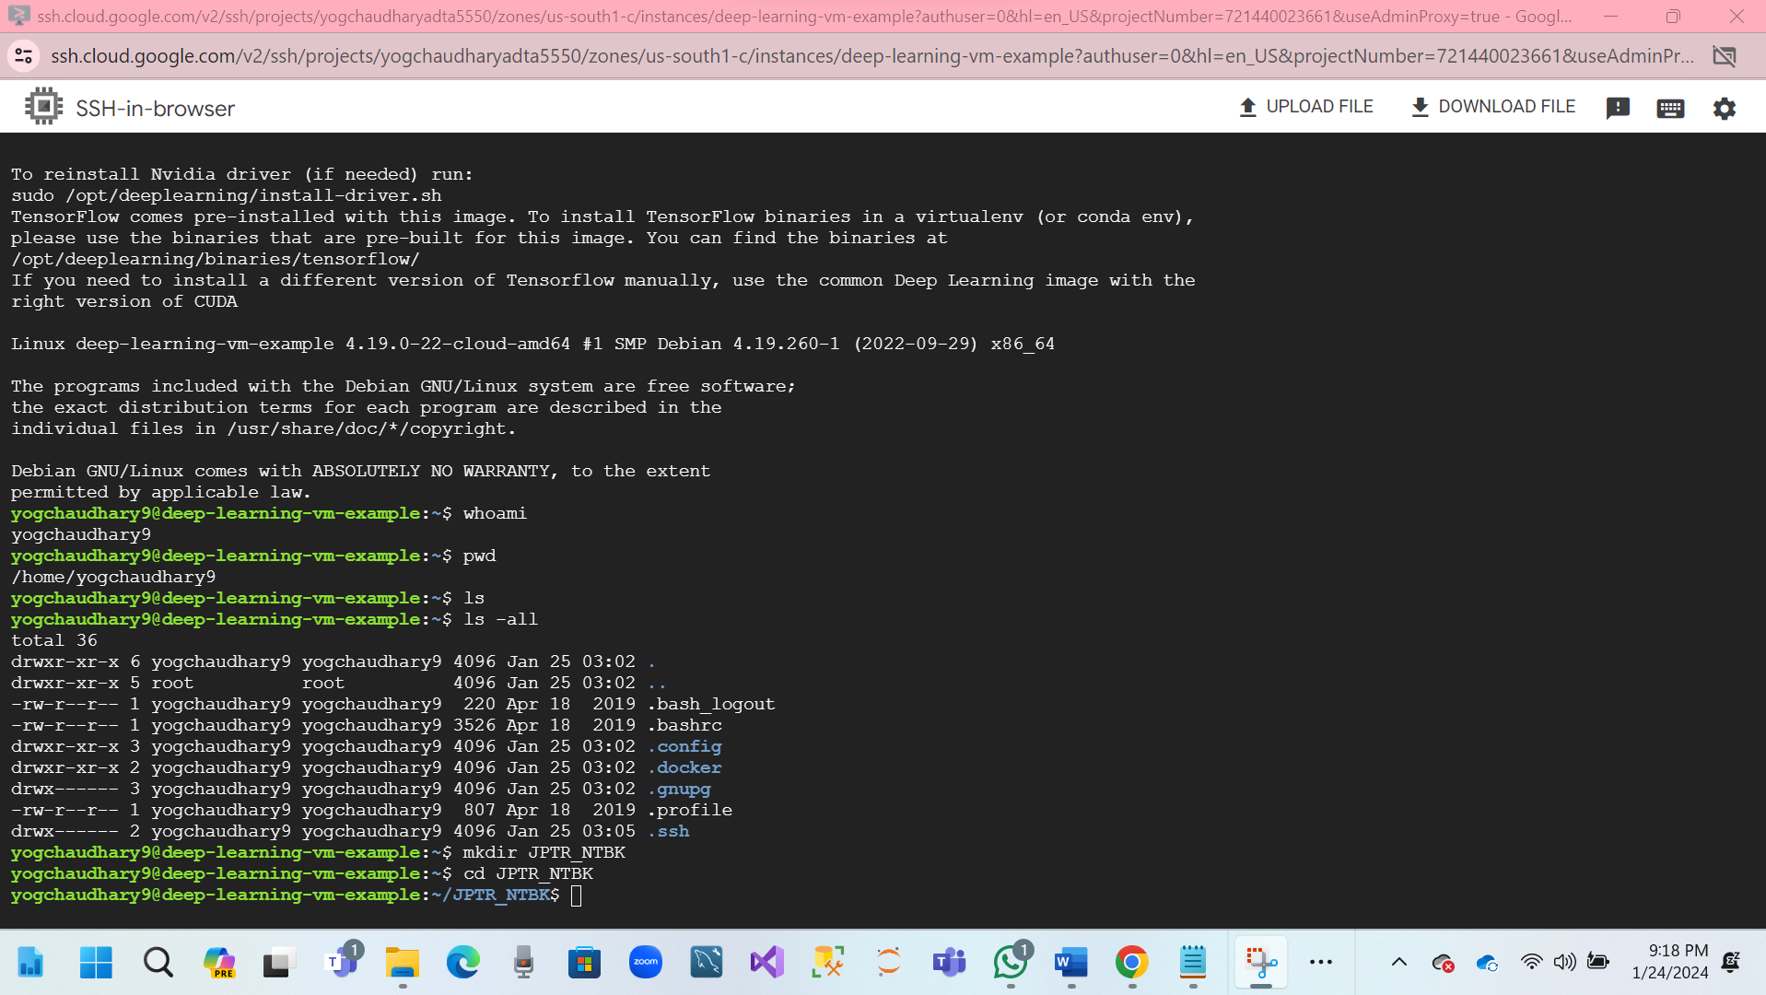

**Question 3.4 Change the current directory to the newly created folder.**

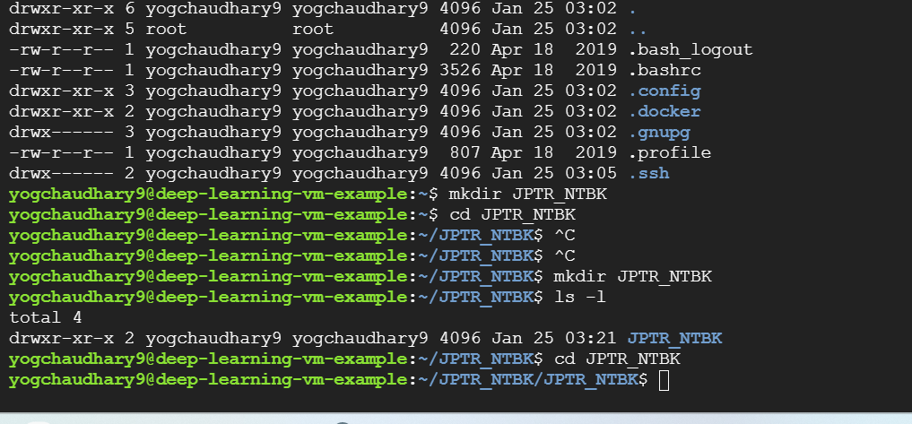

**PART V: Start and Connect to Jupyter Notebook in Remote VM (30 Points)**

**Question 4.1: Based on the lectures, start the Jupyter Notebook server in the remote virtual machine.**

* **cd JPTR_NTBK**
* **jupyter notebook --port=8888**

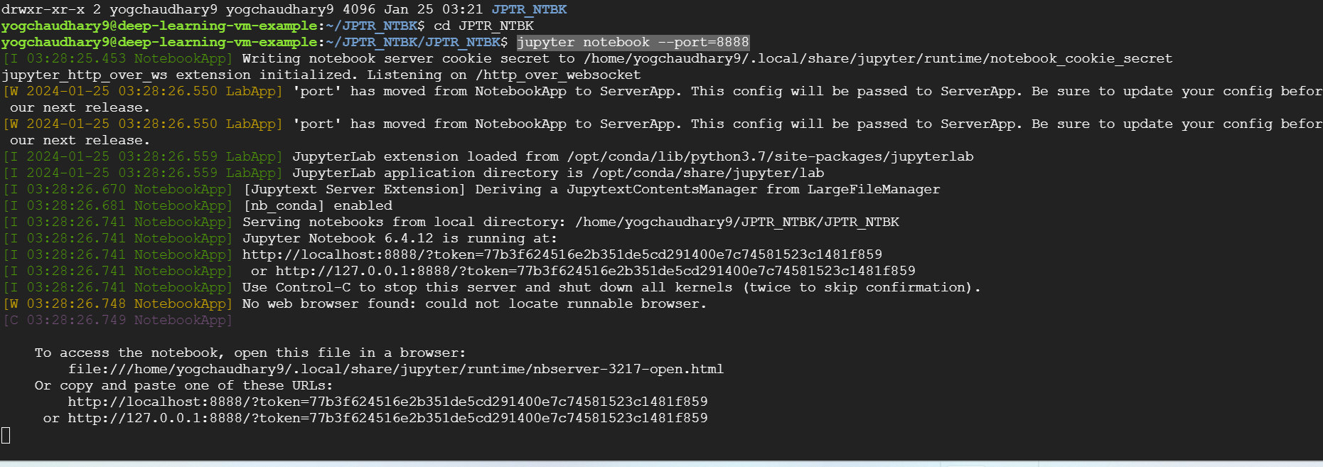

**Question 4.2: Connect to the Jupyter Notebook server in the remote virtual machine (by connecting a Local Computer Port, i.e., 8000, to the Remote Server Port, i.e., 8888)**

**gcloud compute ssh yogchaudhary9@deep-learning-vm-example --project yogchaudharyadta5550 --zone us-south1-c -- -L 8000:localhost:8888**

* **Click on Open Chrome Browser**
* Enter: <http://localhost:8000>

**Enter Token login**

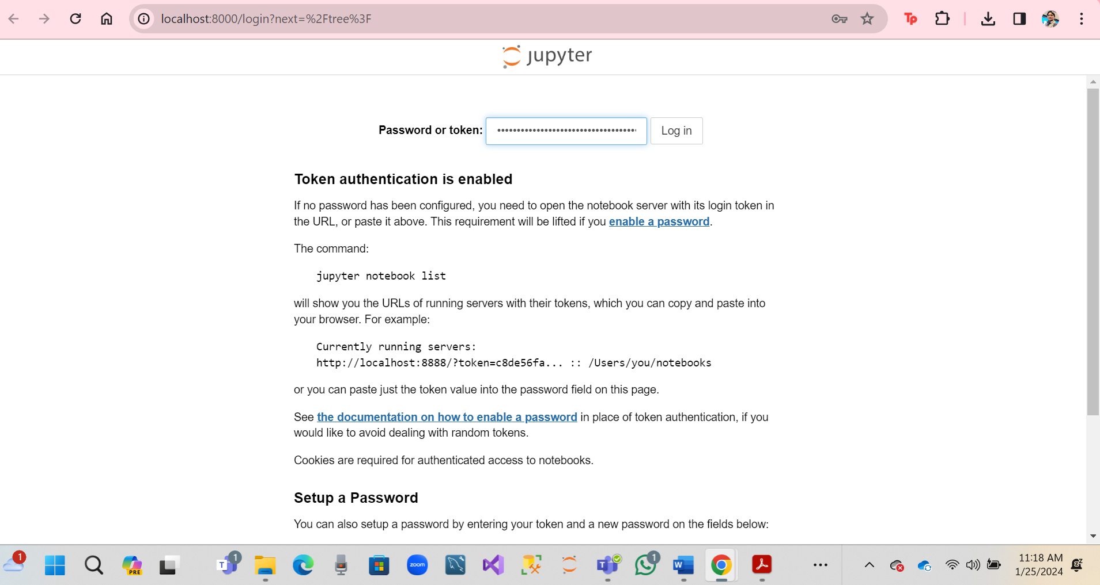

**Open Jupyter notebook.**

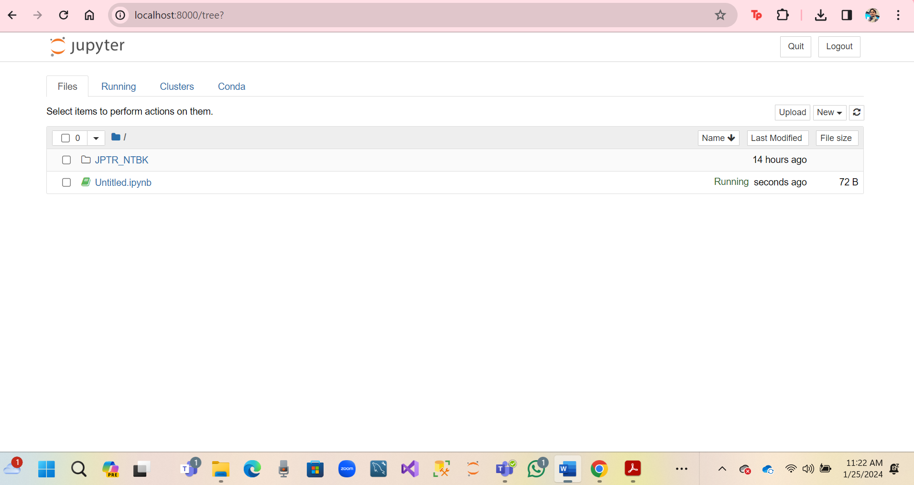

* **Inside the SSH terminal window, which Jupyter Notebook server starts.**
* **Press CTRL + C**
* **Be asked: y/n → Enter y (within 5 seconds)**

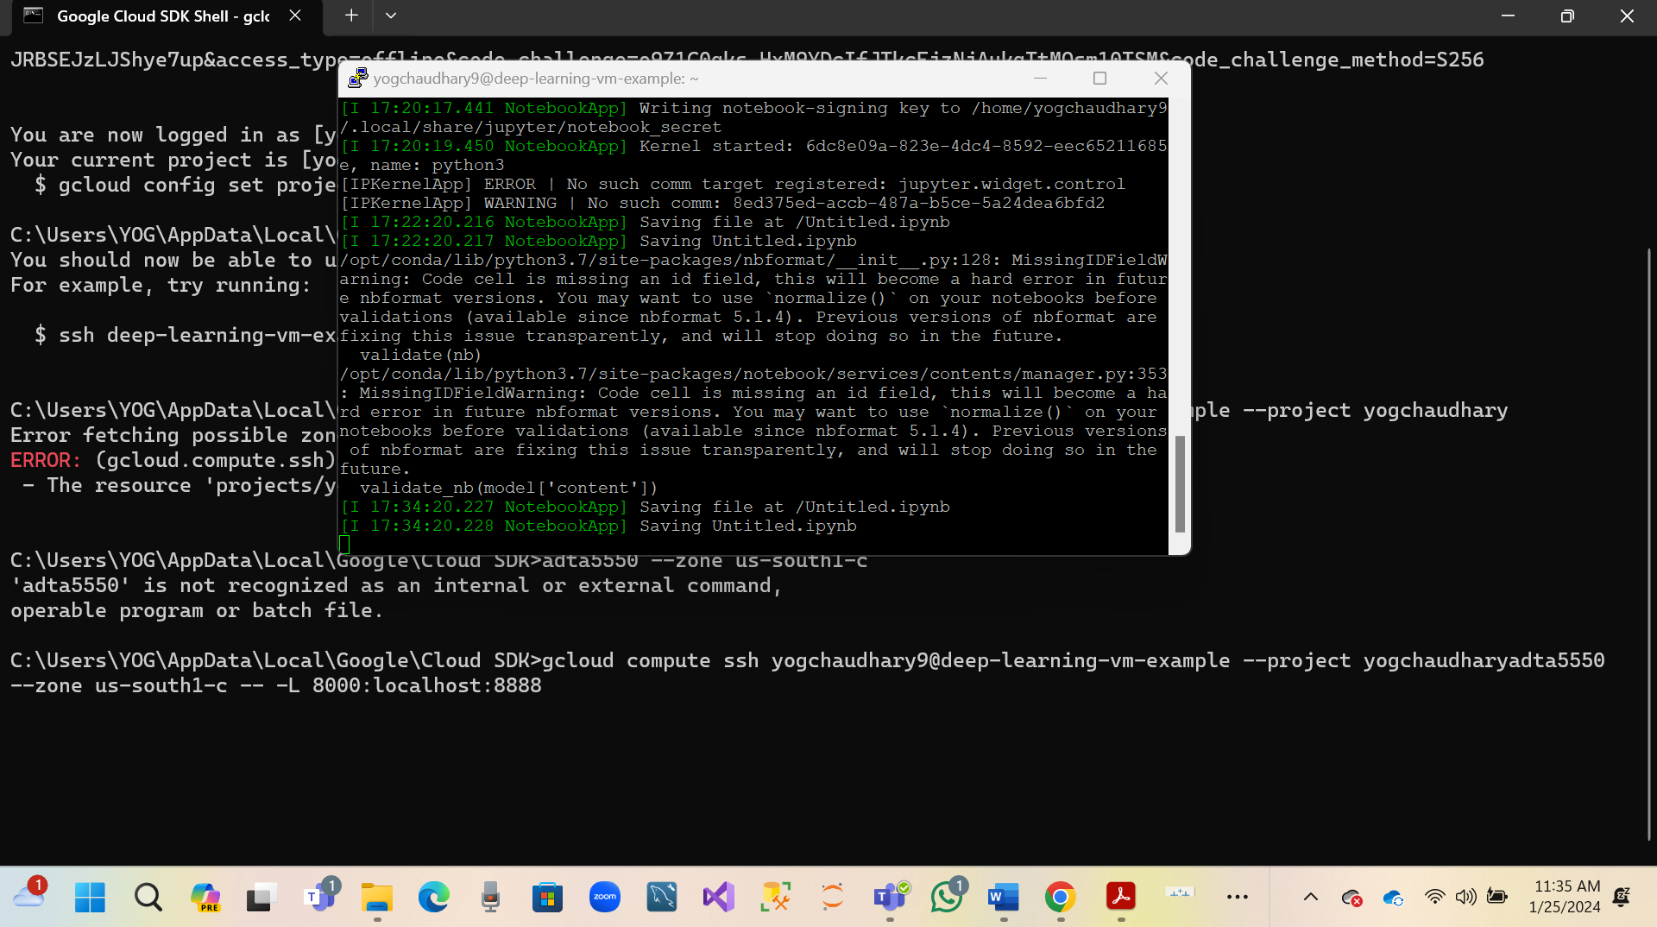

**PART VI: Write Simple Python Code in Jupyter Notebook in Remote VM (20 Points)**

